KURT WILSON

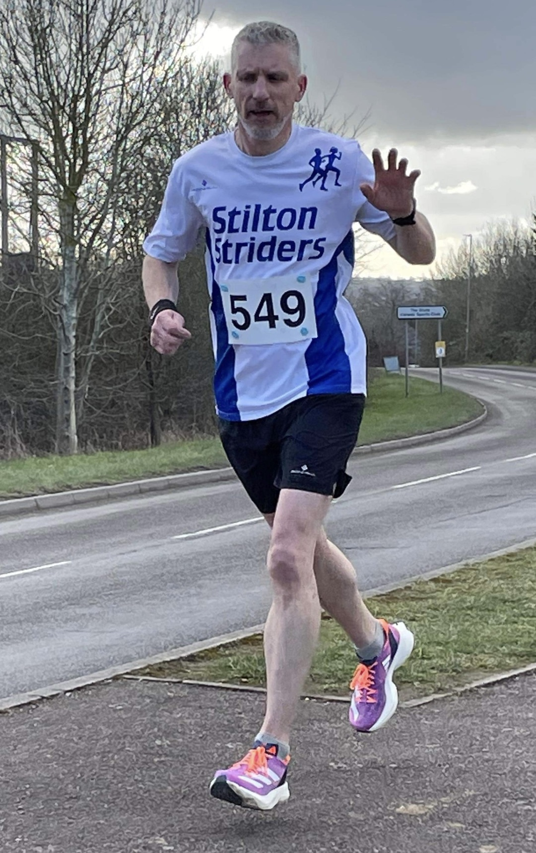

I wanted to join the striders a few years ago to run some local races at a more reasonable cost.

Having done the 3 Castle Challenge (a series of half marathons) in North Wales in 2019 (Now 4 Castle), I thought keeping a bit more local would be a better option. Then Covid decided to shut down the world in 2020 and all racing went to a virtual form which was a good way to get you out but a tad boring running on your own. Needless to say, when the opportunity allowed us to run with others both myself and Mike Williams formed a great friendship in many a 10k throughout the darkness of Covid. We even ran the virtual parkrun thanks to Shane Sharkey for keeping us going on a Saturday morning. Grabbing a post run coffee was an important part of getting us back to social normality. Finally, parkrun was back albeit in a reverse direction at Melton, but that didn’t stop us attempting a reverse PB.

As many of you know parkrun is great for challenging yourself and touring the country or other countries using the same barcode. On top of this a big part again is the post run cuppa, where more friendships are made and this time Rob Mee, Mike and myself would often attempt to dissect our run over a Tea at the Cafe. This led to a spot of tourism around the county with plenty of tea drinking involved. When they both decided to buy me a Stilton Striders T-shirt as a birthday present back in 2022 I thought it was about time to join up and be counted, almost 2 years later than originally planned.

I didn’t think I knew many Striders but then what's parkrun without a bit of healthy competition and plenty of familiar faces. I thought it would be great to run the Livingstone Relays and meet more of you but we didn’t have big entry in 2021. Despite this we still made plenty of noise for each other and the atmosphere was simply brilliant.

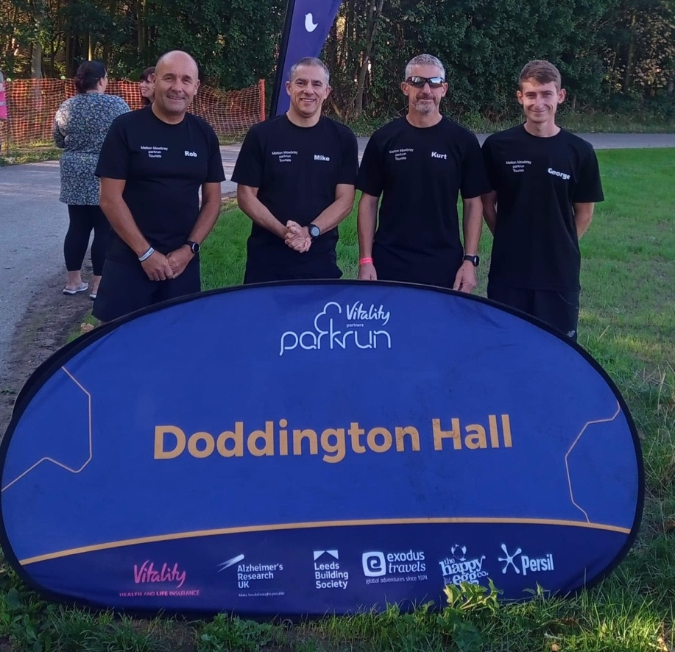

So, it's 2021 and league races are back, sort of. Not knowing the how things went or even how points are scored (still struggle with this) I only managed 3 races last year so didn’t qualify for the league as 4 was required. However, they were a great few race and a good introduction to the LRRL. I finished the season with a couple of cross country races due to Mr G's consistency and we got promoted so well done team. The support for each other was great. So much so that I may have been a bit vocal about this to Chris as it didn’t seem the same in the road races.

Jump to 2022 where friendships and rivalries are in place and the new season is ahead of us but before that I was tasked by our Chairman to reach out to our fellow striders and introduce you to the Livingstone Relays. With more teams of Striders than last year we may just of been the noisiest supporters around. What a morning with a PB for me and many others who ran last year. Can I just say THANK YOU for attending and making it a great start to our running year. Also, THANKS to the club for providing entry and to Andy for sorting out the entry list on the day.

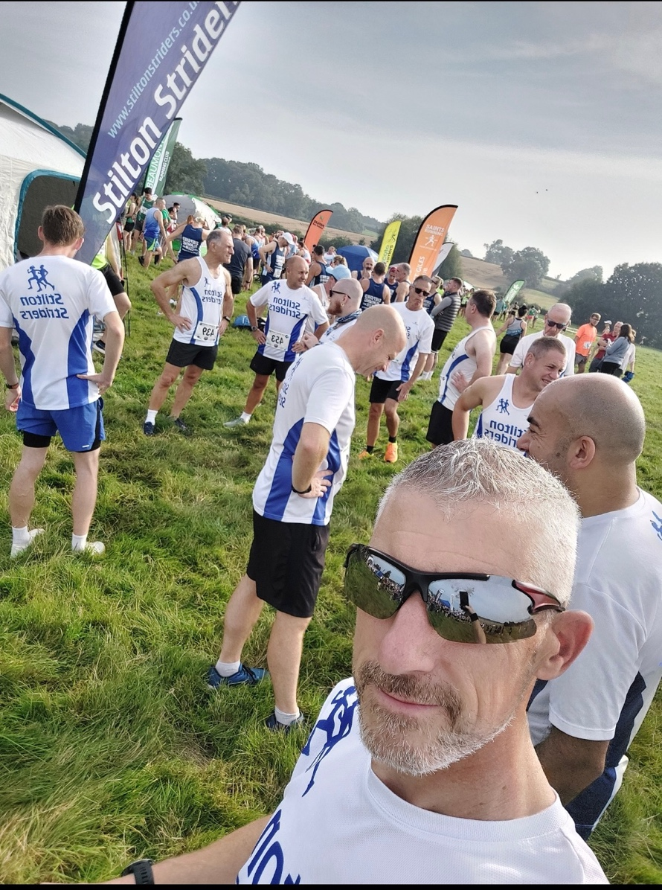

Stilton 7 - my first time running it and in my last age category so standards were a bit out of reach. 50.58.
Kibworth 6 - with a hill or two 43.28. Silver.
Bosworth Half - a PB for the distance but first time on the course 1.41.55 Bronze and my first sub 1.45 Half.
West End 8 - first time and another hill 57.45 Silver.
Swithland 6 - where it started to make sense 47.10 last year - 41.06 this year silver standard and mind blown.
Prestwold 10 - felt confident but ran to the conditions 48.03 last year - 46.34 bronze but a PB.
Desford 5 - another new race for me 35.25 silver and off the back of Holme Pierrepoint series with a 37.02 for 5 miles there.
Joy Cann 5 - what a race 36.58 last year - 34.06 silver standard and another PB.
Rotherby 8 - having already got a silver for 8m I tried half marathon pace strategy for the first 5 and give it what I had left for the last 3 trying to catch Katie Hateley and hopefully push her along to a strong finish if I had anything left (not that she needed it). We caught John Robinson at the end and all 3 of us pretty much crossed the line together what a brilliant end to the season.

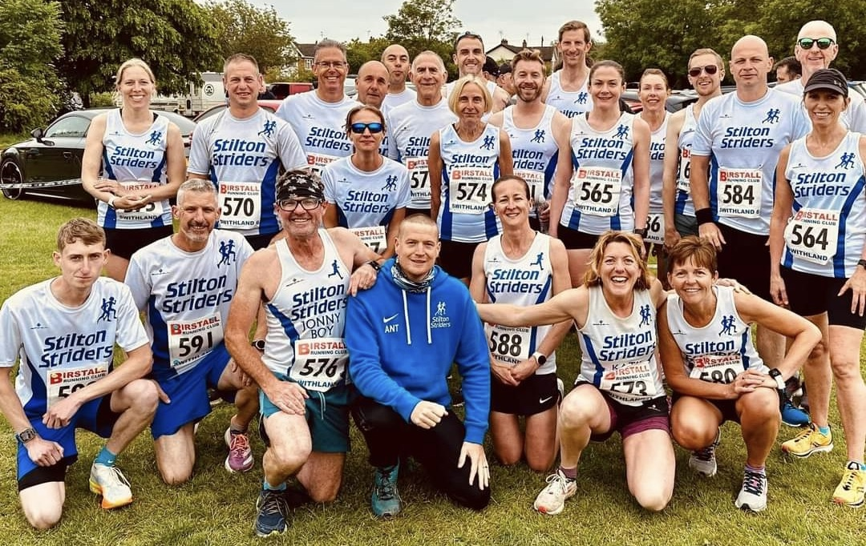

It's fair to say the season has been awesome with plenty of support for each other and a brilliant turnout of Striders at all the races. The banter was on top form and having my son at the races with me made it a special year.

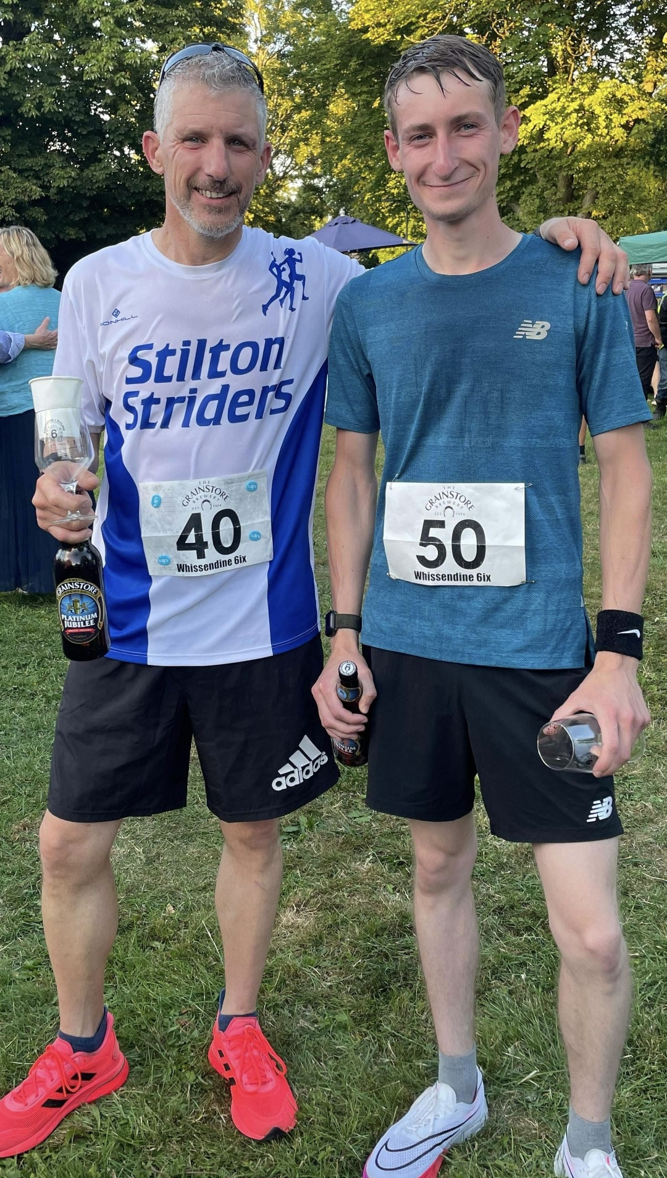

Despite all this I think my favourite moment this year was not about me but a fellow runner who I simply refer to as Legend. I was tasked with picking the London Marathon club place way back last year at our xmas run. At the time I didn't know Mark Preston that well but upon picking his name out of the hat another great friendship was formed. Watching his training and knowing his goal I took great pleasure in keeping track of his progress throughout the marathon, despite myself being in another country at the time. When the result came in and it was a sub 4 I was over the moon for him.

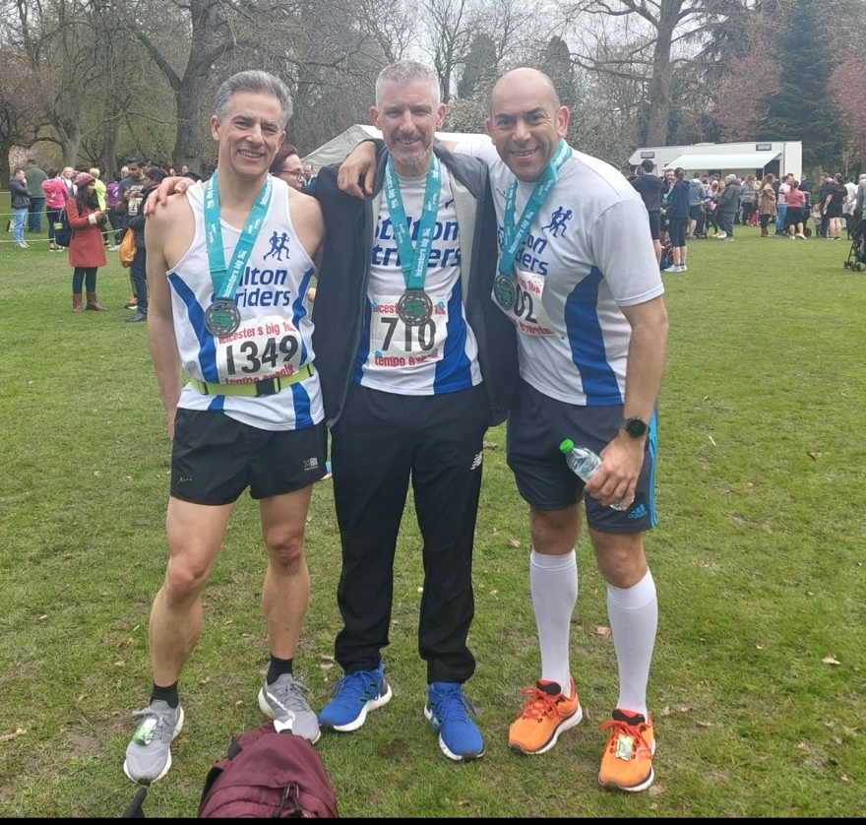

Yes, I have achieved a PB across every race distance I have ran this year some even at the same race as before but nothing gives me greatest pleasure than watching a fellow runner smashing a PB or getting their standards or simply just achieving their goal. I would also like to congratulate the Ladies on your promotion you were all awesome this year.

If you have stayed with this till the end THANKS for reading and being part of my year and don’t think I won't be watching your achievements. That’s what Strava is for, right?

Keep up the team spirit Stilton Striders.

Kurt.

