Striding Around Leicestershire’s parkruns
On Saturday 18th June, 3 Stilton Striders, a Melton Mowbray based running club, and a friend took on a challenge to run all of the Leicestershire parkruns in one day.
So why did Striders Ian Bickle, Matt Taylor Andy Nicholls and John Kerr take on this challenge?
As a group we recently started touring around a few local parkruns and like many ‘parkrun tourists’ enjoyed the experience. It seemed like a decent challenge, but one that was achievable without a lot of extra training.
This needed a little planning though, as we’d have to work out a route to avoid too much driving, check which ones we could access outside normal parkrun time and recce most of the courses so that we knew the routes to follow without marshals to help guide us. While developing our plans an extra hiccup came about as Hastings High School parkrun near Hinckley started – also in Leicestershire. And with a 10th parkrun planned to start soon, the clock was ticking to complete the challenge before that one began too!
We set off on our first run at 5am, running the Belvoir Castle hilly summer route – probably the hardest one of the day - across the fields and up into Stathern woods before heading back with views of the castle to guide us home. Even at that time it was fairly muggy but we were thankful the previous day’s heatwave was over and 17 degrees and a little light rain was more likely.
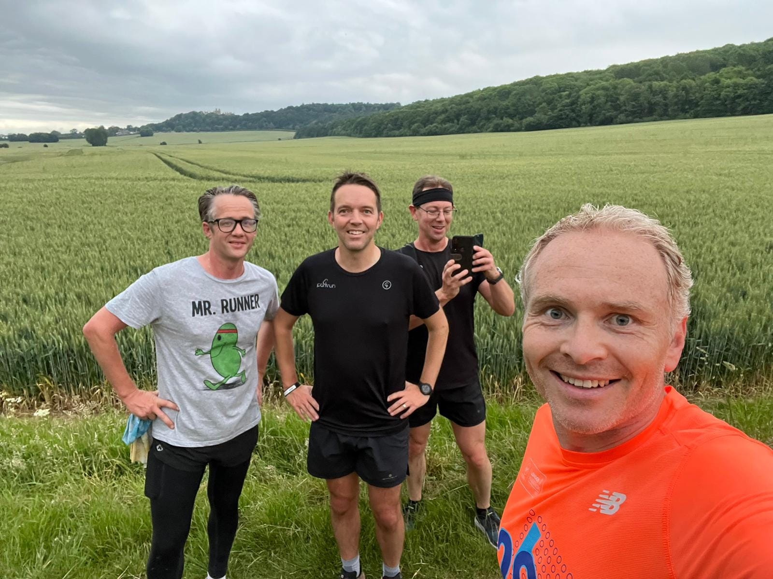
Dishley, Loughborough was #2, running around the rugby club fields and then out and back along the canal which was beautiful in the early morning.
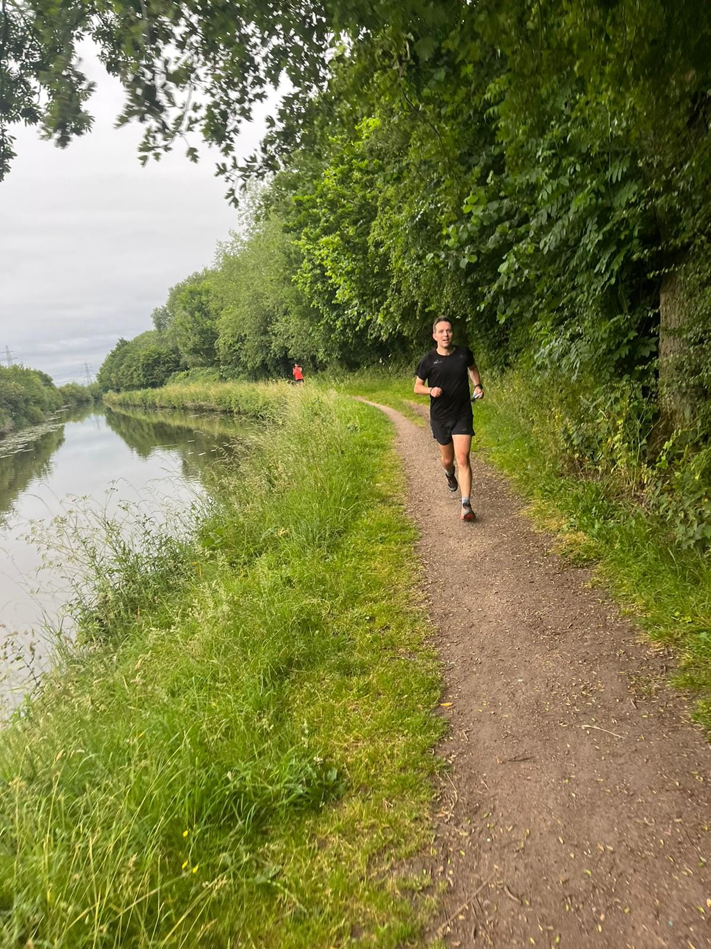
A bite to eat and off to fantastic Conkers, near Ashby-de-la-Zouch and #3 with only a few friendly dog walkers around, compared to the 400+ runners typically cramming the course.
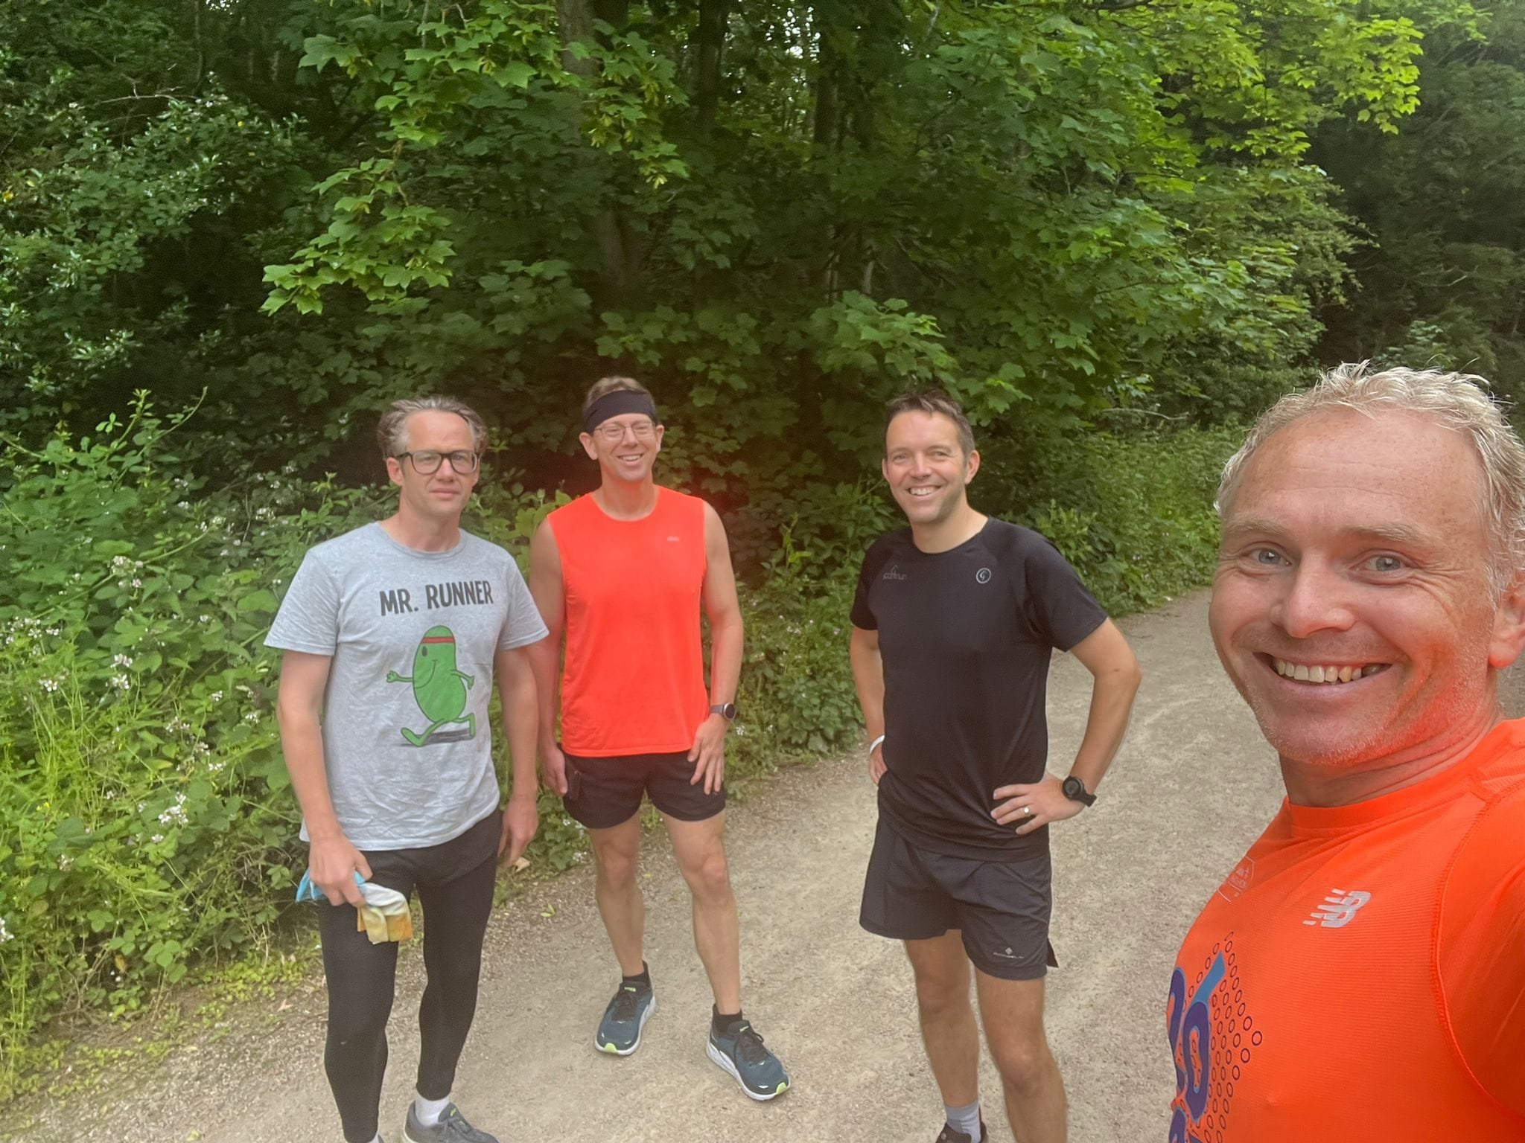
Keeping well to our schedule, after a change of clothes or footwear for some we now headed to Hastings High School, Burbage for the “real” parkrun and #4, arriving early so that we could check-in with the Run Director. Matt had managed perfect timing with this being his 50th parkrun and also his 50th volunteering stint, taking on tail-walking duties with Andy. This made a very pleasant change and inspiration, being around lots of other fellow parkrunners. The event team delivered a very entertaining briefing (with audience participation) and gave us a shout out for both Matt’s milestones and the challenge we were undertaking plus the marshals (and even a doggy marshal wearing a high vis vest) were super-friendly. This was an interesting course with 4 laps of a big grassy field and 3 winding loops around and between the school buildings. Ian got a little carried away and ran under 22 minutes for this parkrun, rather than taking it easy! Another nice touch – volunteers had a free cuppa at the end – which was very welcome.
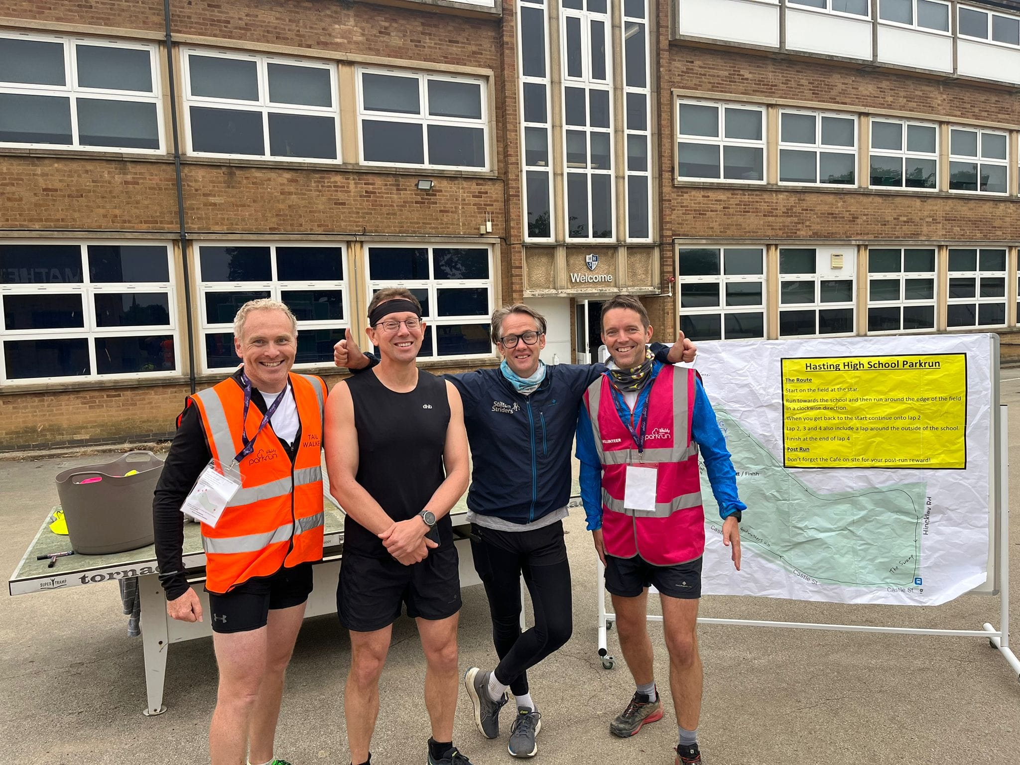
#5 in Market Harborough next as the rain started to fall. Welland Park is a lovely place to run – great firm paths and an interesting windy course that you do 3 and a bit times. By now, we’d eaten our way through many jaffa cakes, banana bread, apple pies, crisps, dates, nuts, grapes, porridge pots, rice bowls, energy gels and sweets to keep us fuelled. Luckily there were public toilets open at this one!
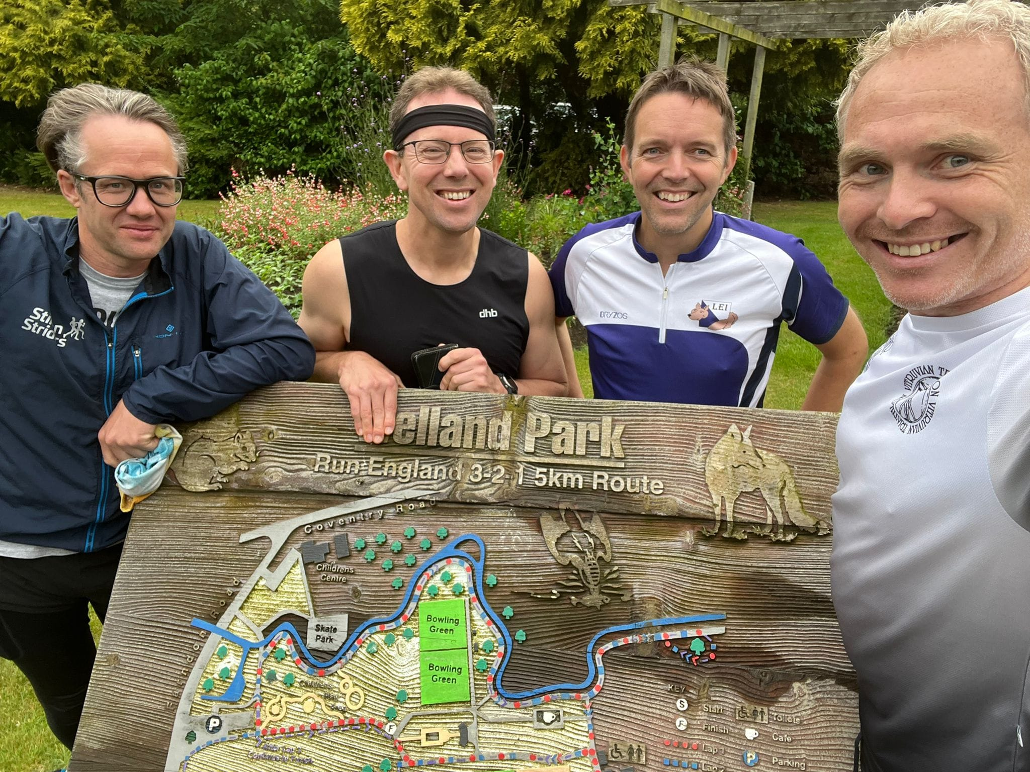
Making our way back towards home, we headed into Leicester city centre for Leicester Victoria park and #6. The fatigue was now starting to bite but a good pace was kept up. It’s a fast course with small undulations and good tarmac paths, starting and finishing by the imposing war memorial.

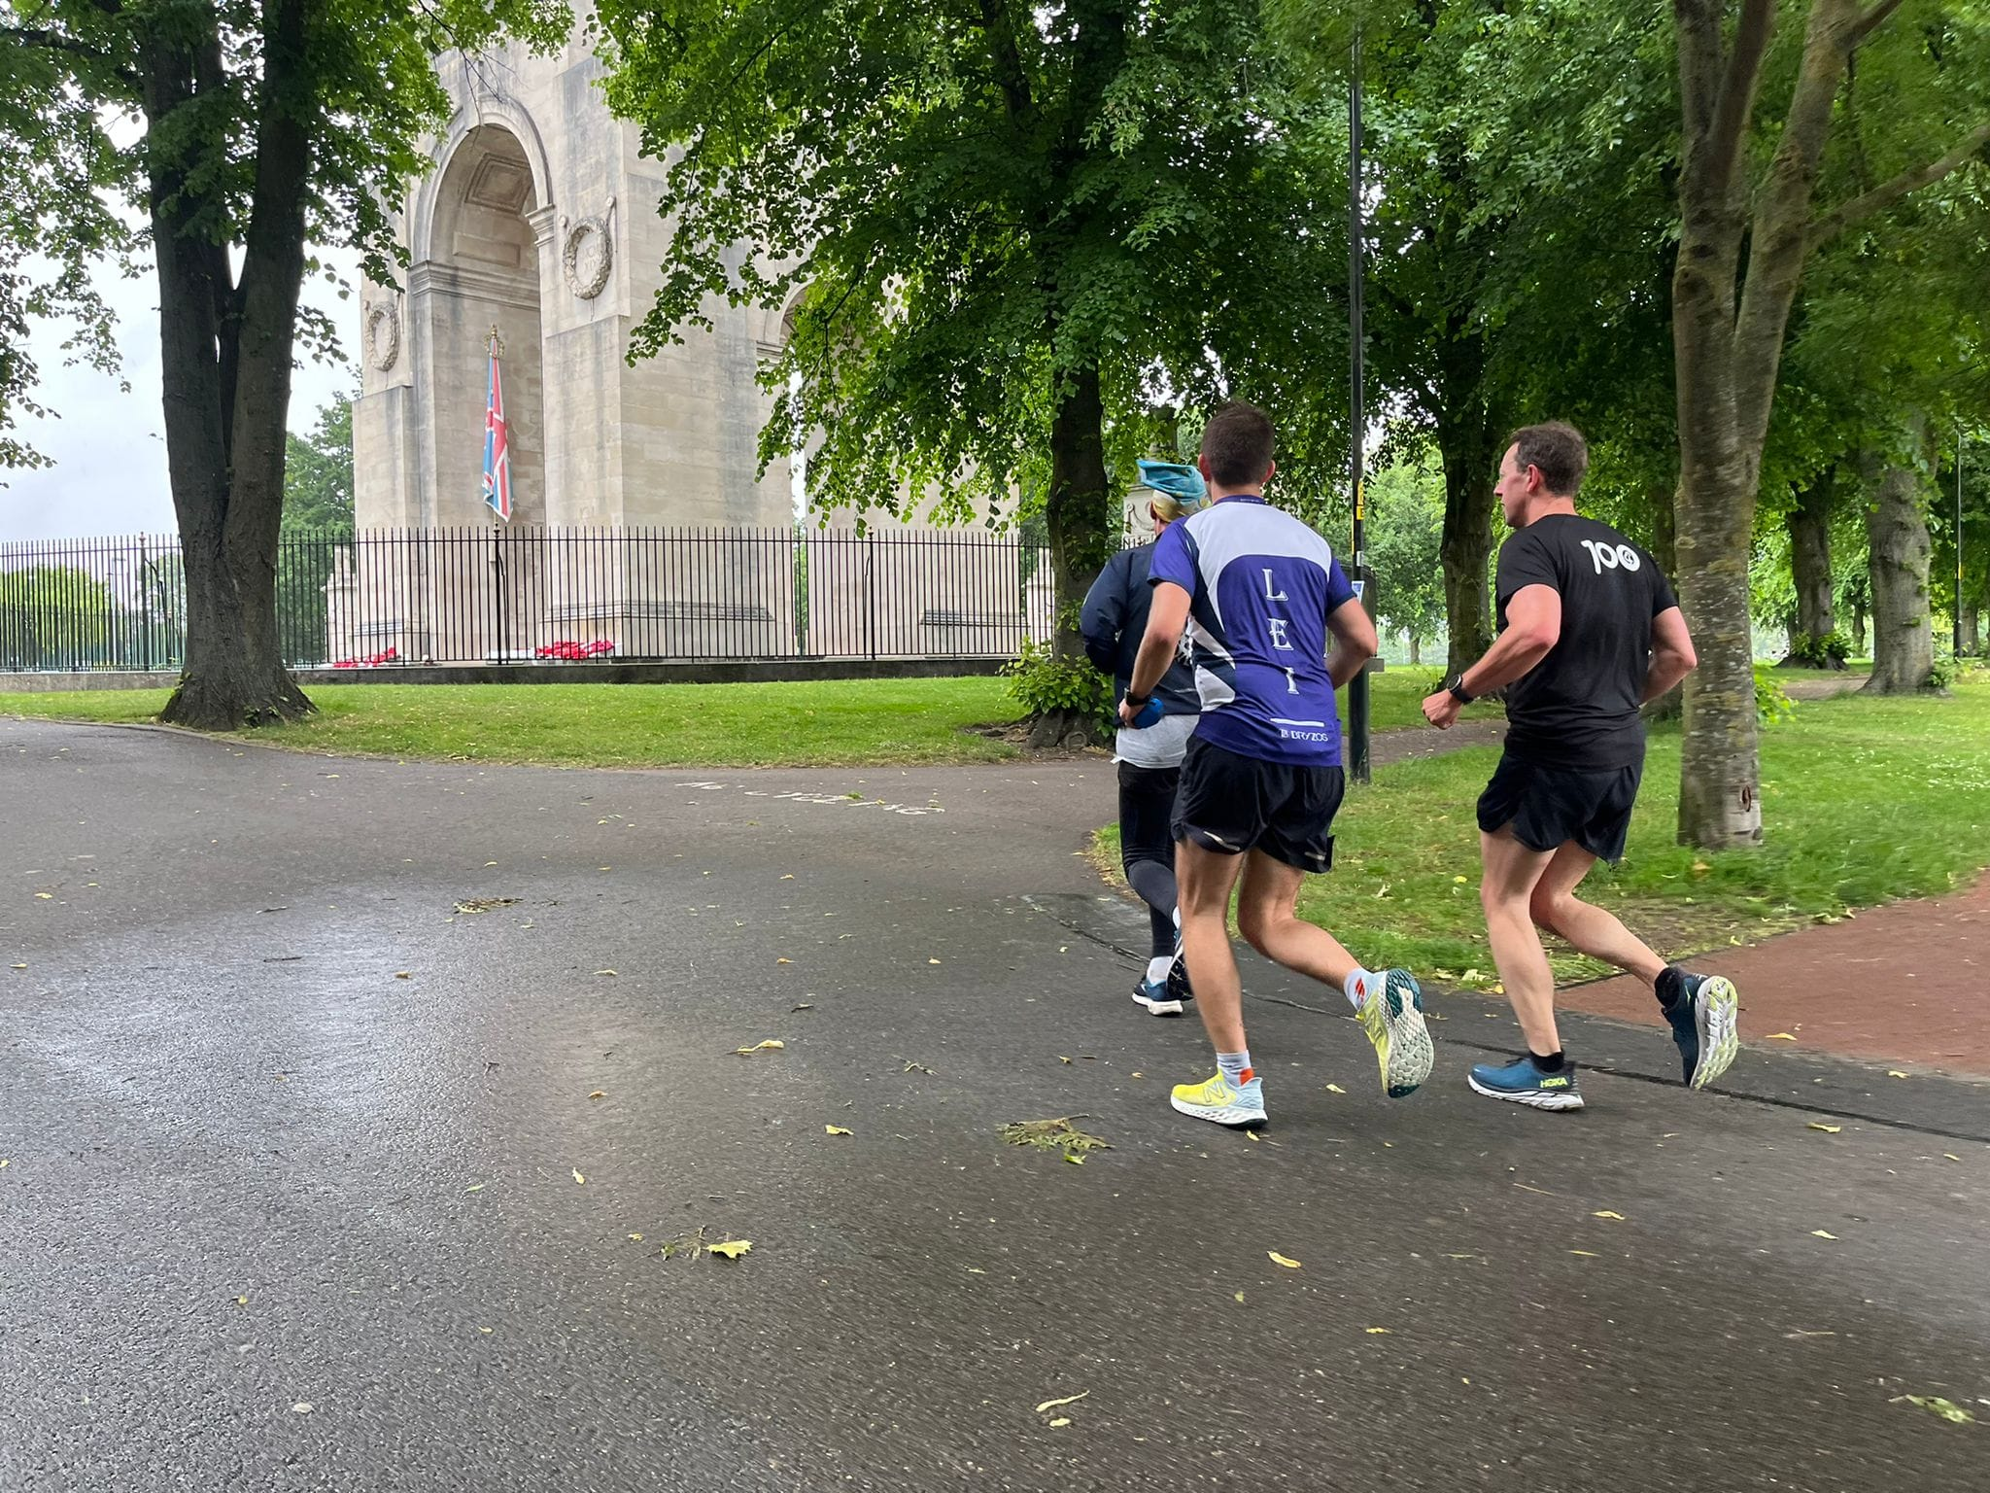
Off to Braunstone park for #7, we weren’t 100% sure on this course. For this and all of the remaining ones, we started each run with moans and groans like we were 30 years older as we’d stiffened up, finding it hard to get going but loosening up within a few minutes. In places in Braunstone park, you can forget you’re in a city, it’s so wide and open. The only obstacles we faced were some protective geese parents with their fluffy goslings blocking the path, so we detoured around to avoid them. Other entertainment was provided by Ian’s eclectic music choices (and dancing) to try to energise the rest of us.
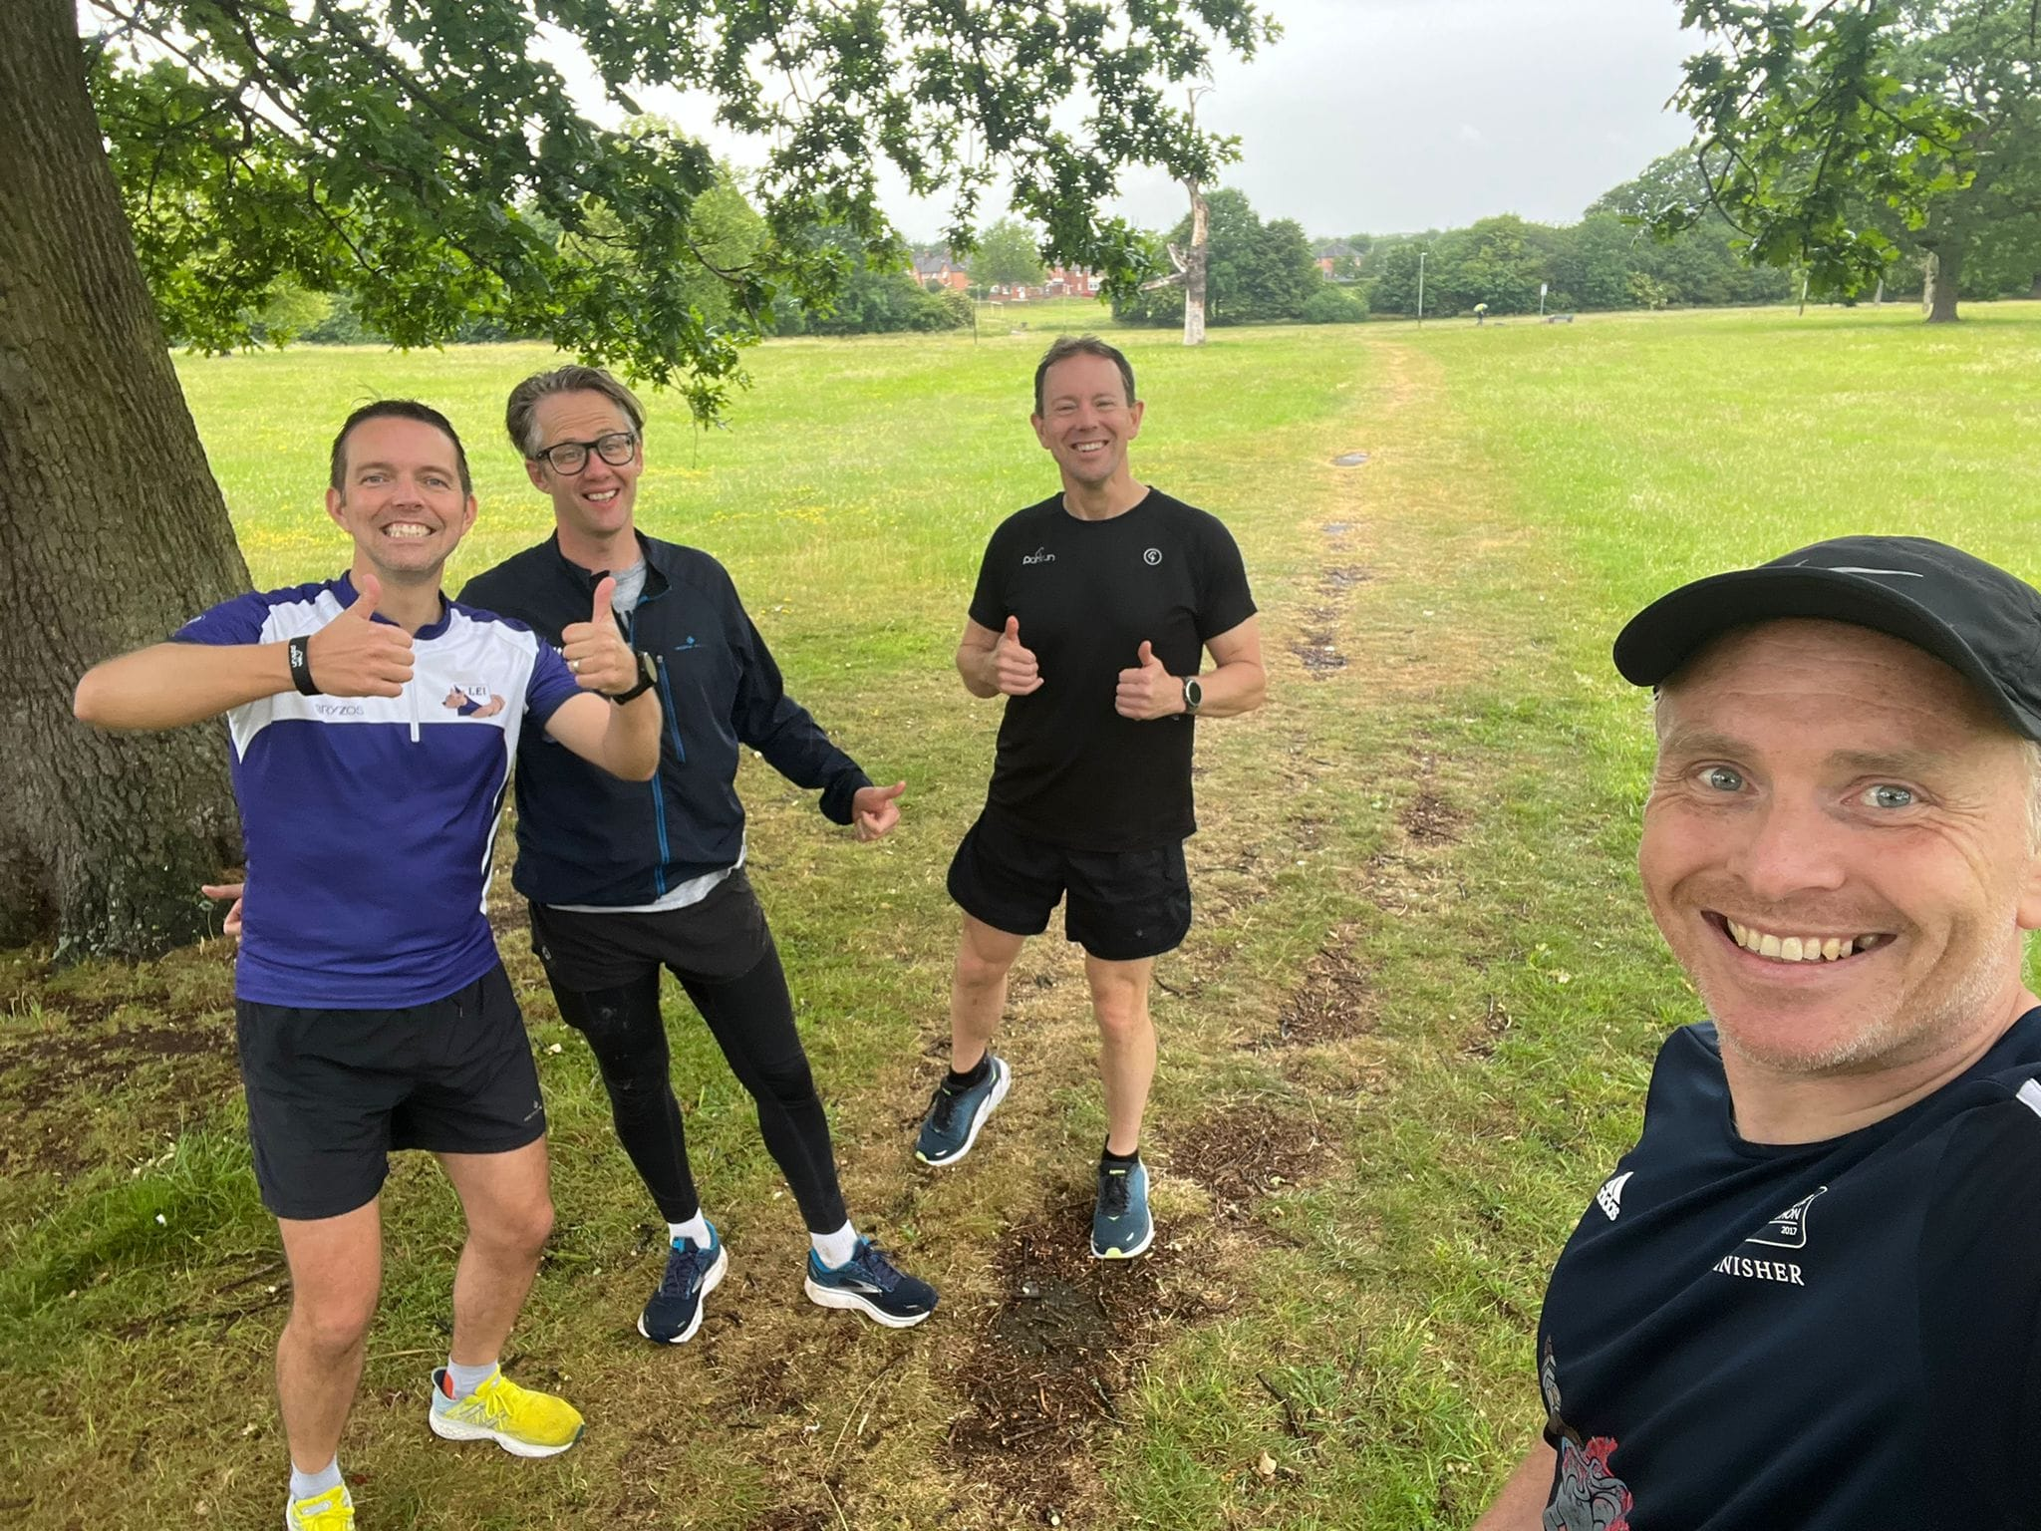
We were definitely flagging now and it was lucky that #8 at Watermead Country Park was the flattest, easiest course of the lot. 1 lap around the sailing lake, then 2 laps of King Lear lake.
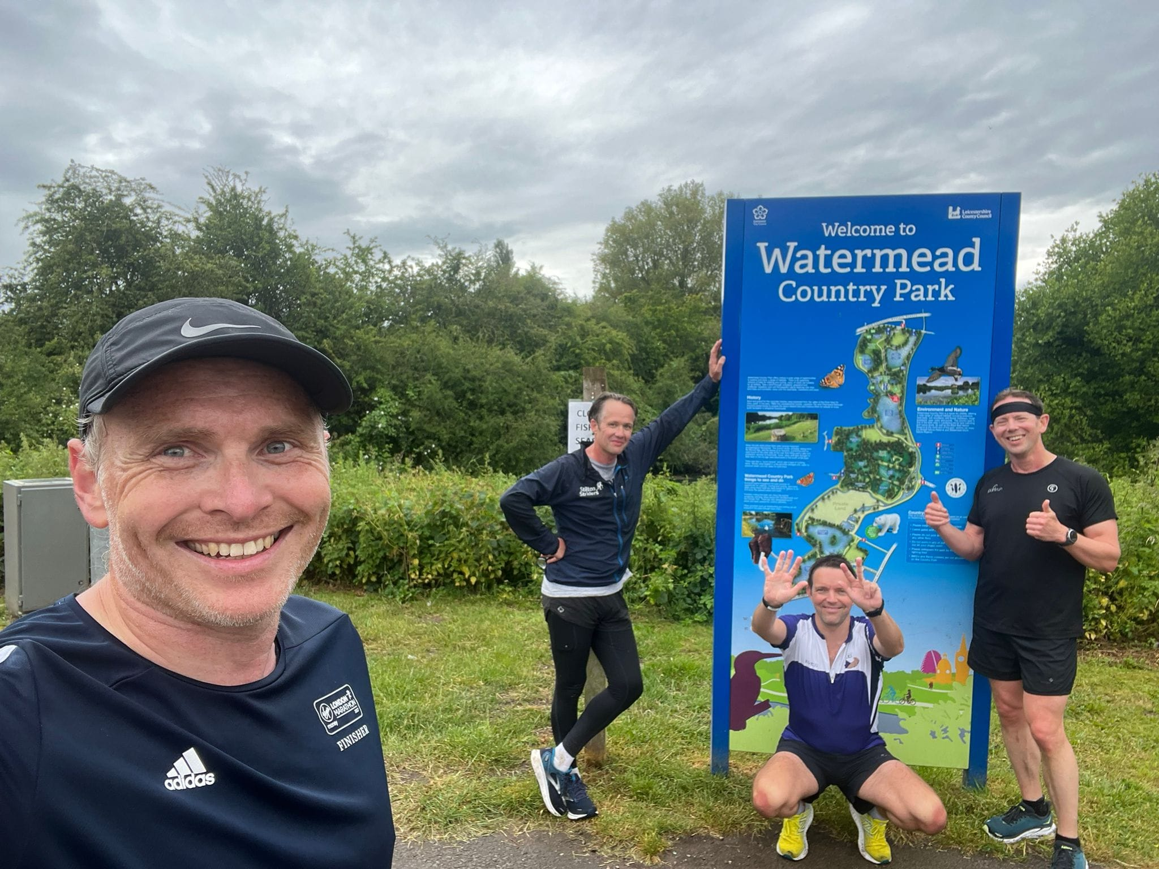
Finally Melton Mowbray for #9 – our home parkrun. On the way there, Matt had leg cramps – not ideal with limited room in the car to stretch. We were met by Matt’s family and his daughter, Ella (16), joined us on the final leg. 40 Oaks hill is always tough, but John found a new lease of life and romped up that both times – we’re working on him to join Striders! Being at our home run was lovely way to finish and the long downhill sections made up for the hills. The icing on the cake (literally) was the tasty coffee and walnut cake Amy (Matt’s wife) had baked which we gorged ourselves on at the end.
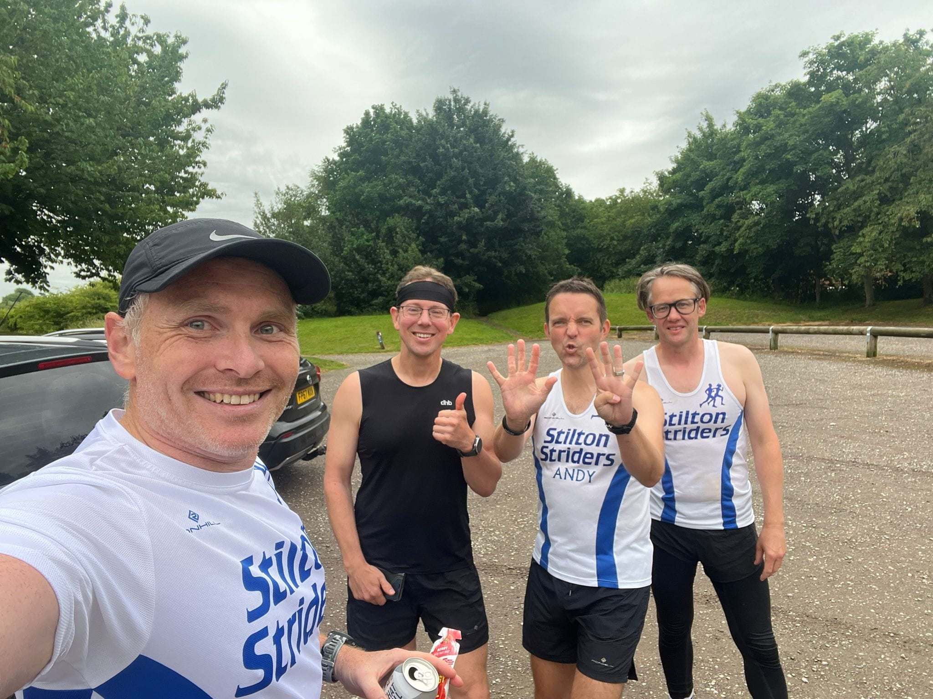
Matt had decided to fundraise for Race Against Dementia to give more meaning to the day and at the time of writing this has raised £500 – thank you to everyone who has sponsored us.
https://www.justgiving.com/fundraising/Matthew-Taylor118
[All photos courtesy of Matt.]

