DERBY RUNNER CROSS COUNTRY LEAGUE
Race 3

SUNDAY 16TH JANUARY 2022
Martinshaw Woods, Groby

Organised by West End Runners
(permit number TBC)

Car parking at Farm Track entrance on Markfield Road

There is no postcode for this venue - all nearest postcodes will take you to the wrong
place. Please use farm track entrance off Markfield Road via Markfield and Ratby only; there is no direct access for the event at the farm entrance on the A50.

Please use Google Map link below which will take you straight there.

https://www.google.com/maps/dir//52.6639257,-1.2664032/@52.6560145,-1.2732358,14z

For those who are familiar with What 3 Words locations the entrance is located at:

https://w3w.co/crowns.rivals.frantic (Crowns. Rivals. Frantic)

If you are approaching from Ratby:
On Markfield Road turn right immediately after going under the motorway bridge.

If you are approaching from Markfield:
On Ratby Lane turn left immediately before going under the motorway bridge.

CAR SHARING IS ESSENTIAL

CAR PARKING SPACE IS VERY LIMITED
3 OR MORE PEOPLE PER CAR PLEASE.
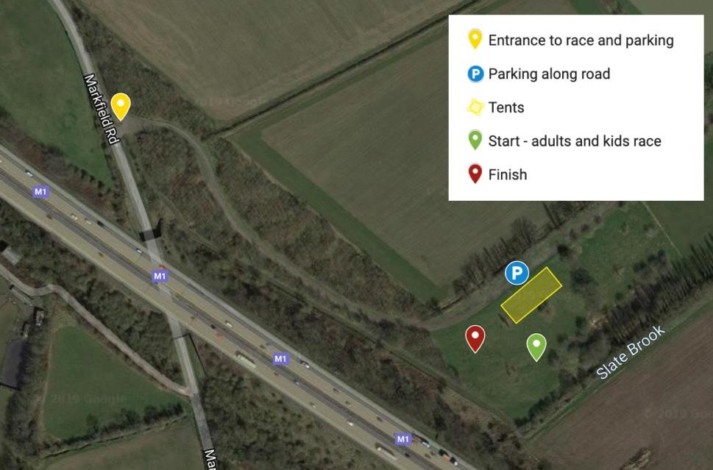
There is plenty of space for club tents,which can be dropped off right next to the arena. Please note that it is strictly no dogs on the Groby Lodge Grounds where the race start and finish area is located.

Start times |  | Entry
Junior race: 10.20am |  | Adults £7
Men’s race: 10.55am Ladies’ race: 11.05am |  | Children £2

Entry price includes a donation to the Woodland Trust and the Groby Lodge Estate’s charity of choice as a thank you for allowing the race to go ahead on their land.

Notes

The route on both Junior and Senior courses will be marshalled, and signposted with tape in the trees. Please keep to the route at all times.

Please take ALL litter home with you.

Please take care when parking and leaving as the grass can become very slippy. Take it slow to prevent your vehicle from getting stuck.

Junior races:

For those that ran our previous event, the Junior Race will run on an identical course to 2019.

Primary age: one lap of grassy/muddy paths around the start/finish area. Approx 1 mile. Please note we are now governed by schools xc rules so minimum age for juniors is now school year 3.

Secondary age: two laps of grassy/muddy paths around the start/finish area. Approx 2 miles.

Route is available to view online here: https://www.mapmyrun.com/routes/view/4778515012

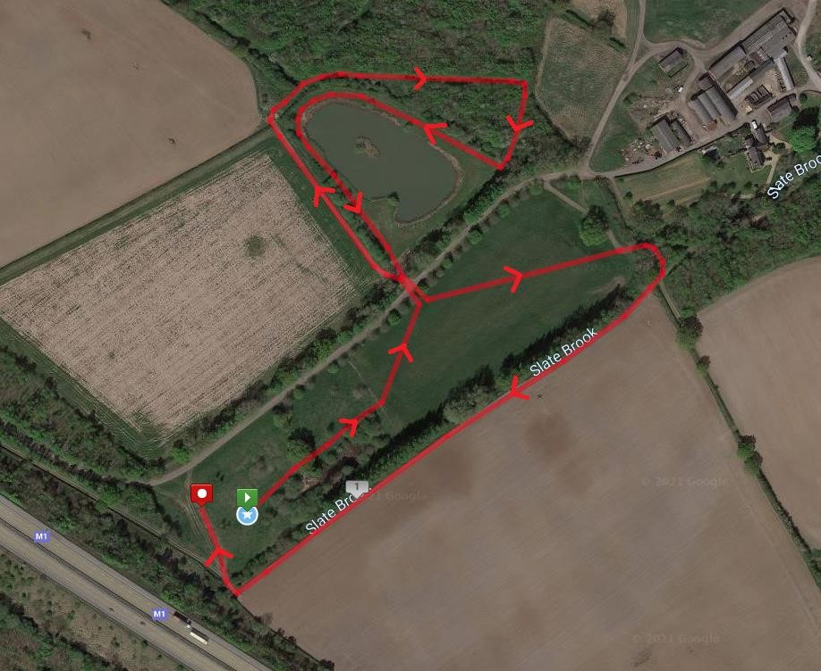

Senior race:

One single lap of Martinshaw Woods and surrounding fields. Distance approx 5.7 miles.

The route is very similar to that of 2019, with one minor alteration in the woods west of the motorway which have now recovered from felling, allowing us to keep to the nicer paths in the woods rather than rejoin the main forestry track.

Split Start: Men’s race: 10.55am, Ladies’ race: 11:05am. Adult race minimum age 17.

After an initial start across the open grass field, the route goes uphill early on around the edge of the farmer’s field before a left turn into the woods at a bit of a pinch point approx.
0.6 miles into the race. The route then follows a nice mix of single track and wider woodland paths around the woods with generally plenty of space for overtaking.

After a short section in the open fields south of Martinshaw Woods you will cross over the motorway bridge for the first time. Please keep left at all times on the bridge to avoid runners coming back in the opposite direction. The route skirts the edge of a small woodland car park before doing a loop round more woodland paths before coming back to the motorway bridge.

From there you turn left and head in pretty much a straight line back through the woods with a lovely, muddy downhill section along the edge of the farmer’s field all the way back to the finish line.

Route is available to view online here: https://www.mapmyrun.com/routes/view/4645479925

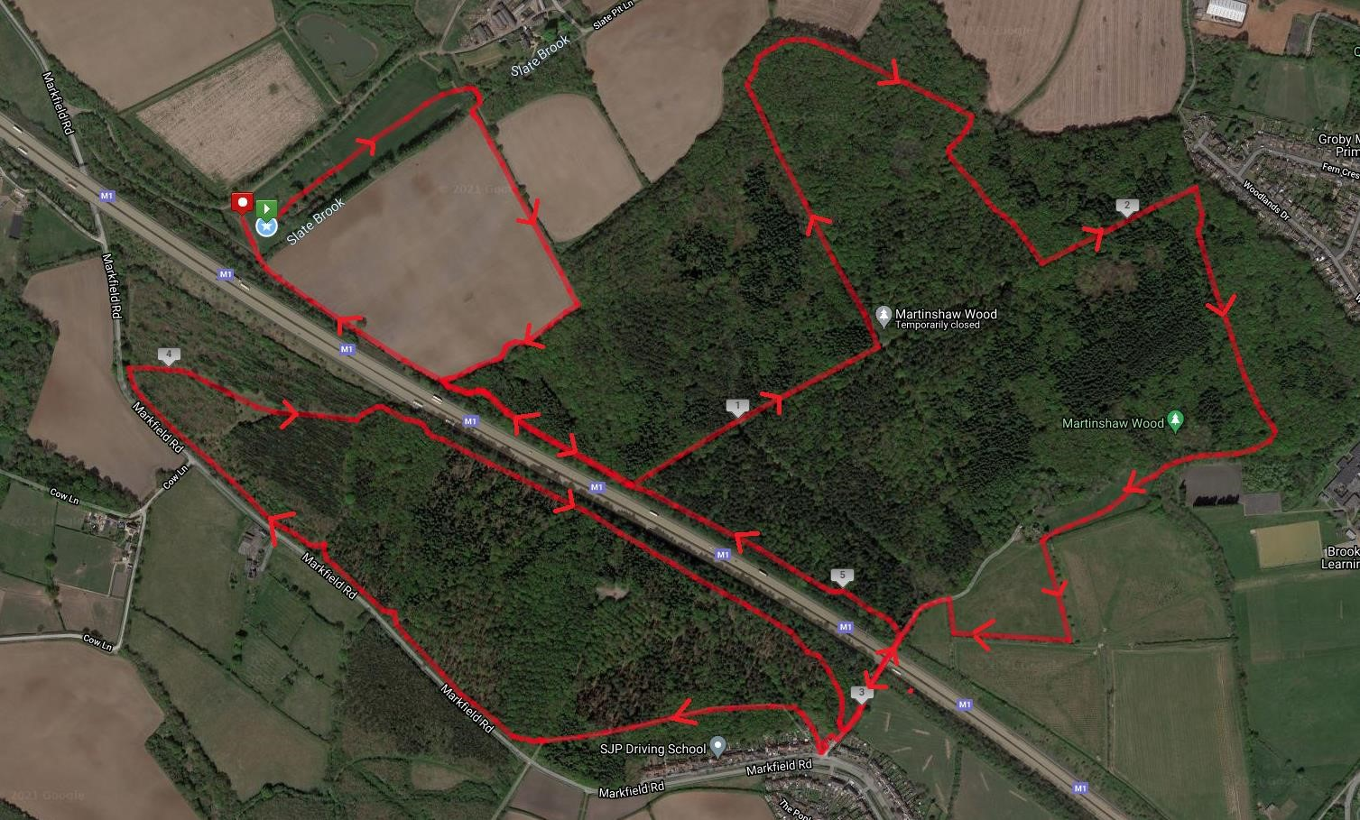

The Senior’s course runs through public woodland - please be courteous to other members of the general public in the area.

Hazards & Terrain

There are two sections of concrete path as you cross the motorway bridge, along with one short section of packed gravel path.

Otherwise predominantly grassy, muddy, and in some places wet woodland paths including lots of tree roots, tree stumps and low level branches.

One very slippy bridge which will be marshalled but strictly no overtaking on the bridge please.

Shoes with studs (not spikes) advised.

Post race venue

The Plough Inn, Burroughs Road, Ratby, LE6 0XZ

Thank You!

Please do join us in saying a big thank you to everyone out marshalling, helping with car parking, setting up the race etc. on the day. They have all given their time freely and we couldn’t hold this event without you!

A big thank you also to the Woodland Trust and the Groby Lodge Estate for their generous support in allowing the event to go ahead.

For further details

Please contact:

Andrew Ward or Laura Davison, West End Runners

Email xc@westendrunners.co.uk

