Member profile Vicki Lowe

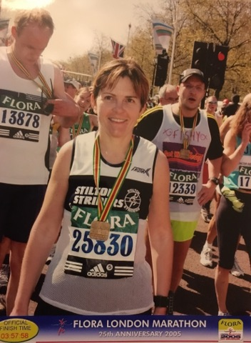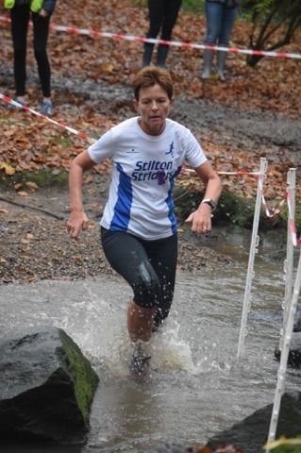

Vicki started running after she had her daughter Beth (now 25) and in her first year she went from not running at all to running the Nottingham Half. Vicki avoided sport at school and was musical. While on maternity leave she would have her trainers waiting by the door for her husband Tony to come home from work so that she could get out for a run.

Vicki first joined the Striders not long after and on her first day there met new runner (and now great running friend) Sui Cushing (former Strider) who had just moved to the area. Sui and Vicki have been running most Sundays since and the conversation has turned the miles into smiles.

Not long after Abi Arnott joined Striders and the two became three. Vicki said that she would “not want to run without my lovely running buddies ‘the girls’,” as well as Michelle, Kirsty, Helen and more recently Julie and Nik.

Vicki considers her best achievements in running to be marathon running. She loves the feeling you get when you have completed a long run so relaxed and being able to eat what you fancy. She feels proud and privileged to have ran 13 London Marathons (and probably as many Ashby 20s) and loves everything about this race. Even watching the London Marathon brings a tear to her eye. Other marathons completed are Edinburgh, Manchester, Leicester, Toronto, Medoc (wine run with Julie such fun), and Boston UK.

Vicki now has a new goal, to complete the six major world marathons (if the cost allows). Having run Boston UK this year in 3.39 she achieved a qualifying place for age in Boston USA next year, a dream place to visit and race - ‘Boston for Boston’. This year she ran the Berlin Marathon for star number two and this was a great experience.

Striders have been a big part of Vicki’s life and she particularly enjoys the team aspect, running for many years in the Leicestershire Road Running League. It is through this league that she discovered the enjoyment of ‘racing’, not just chasing your own running times but chasing the person in front of you. Phil Douglas (former Strider) encouraged her running in the early days and in his words “look at the person in front of you and chase them”. As a vet runner now she enjoys competing against her age group.

Vicki wants to mention her husband Tony who has always supported her running (he knows what she’s like when she doesn’t run). All those times when we have to leave early on a Saturday night social as she has a race in the morning, and the pile of ironing that gets done when she is out on a Sunday morning. And their marathon trips away – “you can have a weekend away without doing a marathon”. Vicki’s final words are that she hopefully has many more running years to enjoy.

