Sharon and Robert Mee

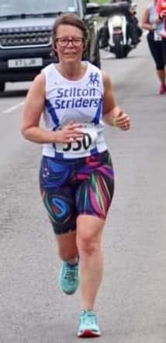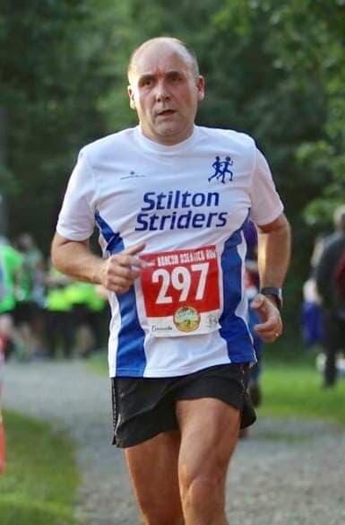

Sharon started to run on her own by downloading an app but gave up twice! So on Monday 20th June 2016, she plucked up the courage to go to MRC’s C25K group. She said: “We were given a warm welcome from our leaders who explained the programme and told us that we would be able to run 5k in 10 weeks’ time – we all laughed!”

She met a fabulous group of ladies who chatted and shared out-of-puff breaths. She is now proud to call them friends and she still has that close group of running buddies made in those first weeks. Sharon graduated from C25K and moved to the regular 3 mile Monday night group, then the 4 mile and now enjoys a social 5 miles each week.

Shane then told her about parkrun and encouraged her to come and give it a go. So, fuelled with enthusiasm, Sharon registered and went off to parkrun with her barcode the following Saturday and managed a run/walk in 43 mins. This quickly became a weekly fixture in her calendar with a little improvement seen each week.

Hoping to improve further Sharon asked husband Rob to buy her a pair of ‘proper’ running shoes for Christmas and on Christmas morning made him go and do parkrun with her so she could wear them! Although a keen cyclist, Rob always maintained that he was not a runner as he could never breathe properly but he ran with her and decided to come and have another go on the following Saturday. As they say the rest is history and Rob now beats me hands down with a PB of 23.14 against Sharon at 29.28, although their enjoyment of a cup of tea in the café afterwards is equal.

After getting the running bug, Rob started to go to MRC on a Monday, running with the 10K group. These weekly fixtures became part of their training over the summer for their first half marathon in September 2017.

They joined Striders last year as they wanted to improve their running and had been recommended the technical sessions by an existing club member. This seemed a natural step to take their running further. Sharon managed to knock 10 mins off her half marathon PB and Rob 13 mins off his time as well as running league races and recently taking part in the Three Club Challenge proud to wear their Striders shirts. Rob also completed a 30-mile ultra in May this year!

