Leigh Pick

“I first started running again when parkrun came to Melton, it looked like a nice way to make more friends and get back into something I used to enjoy. Then it started, parkrun obsession, it’s not a weekend without a parkrun! During this time I lost more of my sight and now rely on the support and good humour of a Guide Runner to complete any training run, race or challenge.
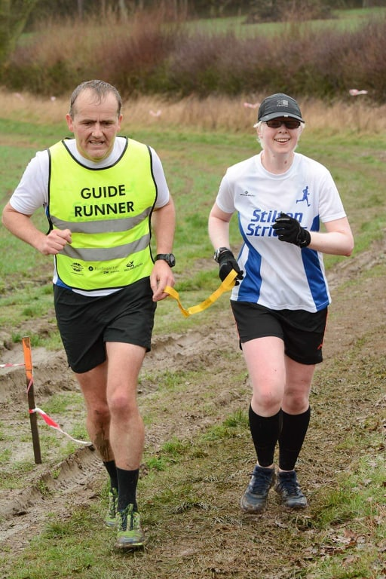
I went from challenging myself each week at parkrun to looking for opportunities to progress and the lovely volunteers at parkrun told me about Melton Running Club (MRC) on a Monday night. Free to attend and run by volunteers it was a step up from parkrun but with equal support and friendship. 10Ks and half marathons followed and then the need for a bigger range of challenges: cross-country, fell racing, PBs - I needed a club for this and Stilton Striders was the next logical and equally friendly step in my running journey. Melton really does have the beginner to ‘slightly’ more serious runner catered for - what an awesome community.”

.

