Greeba Herd

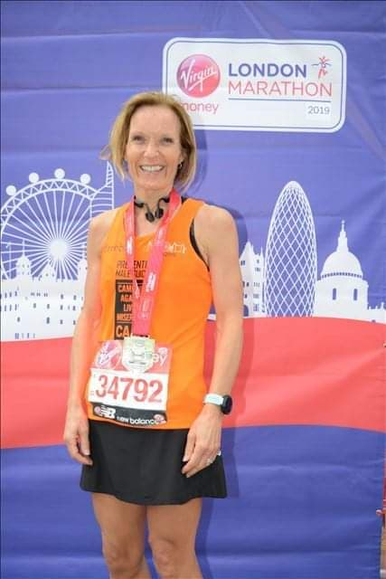

Greeba didn’t start running until she was 47 after not running since school and in her words she hated it then. She first got the bug after Kathy Walsh and Greeba started to walk her dog while the kids were at horse riding and then Kathy gradually persuaded her to try a little jog over increasing distances each week.

Greeba initially thought she was going to die the first time they ran for more than 5 minutes but as she progressed she joined Melton Running Club (MRC) and then parkrun. At first Greeba wouldn’t dream of going running on her own due to her low confidence and worrying what people would think, but now you can’t stop her.

Once she started running regularly, Greeba’s dream was to run the London Marathon so she entered Nottingham with the aim of achieving a Good For Age (GFA) time to gain automatic entry to London. Unfortunately, she missed the time needed by about 15 minutes, but undeterred Greeba decided to try again at the Boston UK marathon the following year.
The majority of her training for this was done with Michelle Farlow, Vicki Lowe and Abi Arnott, whose encouragement and support helped give her the confidence that she might actually achieve what she had set out to do. Then when Greeba mentioned that she was doing the marathon to Jon Wilson, he kindly cancelled a race he was doing on the same day, signed up to do Boston and paced her to a Good For Age time.

That gave her entry to London which she ran in April this year, in a tremendous time of 3 hours 28 mins followed by Dukeries 40 two weeks later in a time of 6 hours 56 mins. Greeba has achieved Gold Standard times this year in V45 age group at Rutland 5k parkrun - 21.03; Belvoir Half Marathon in 1 hour 36 mins, and Ashby 20 mile in 2 hours 40 mins. She then went on to achieve her first Gold Standard in her new V50 age group in June at the Crazy Cow 10k - 46.45.

Greeba believes she has been incredibly lucky and benefited from many people’s expertise and support along the way, all of which have helped her improve her running style and times.

“Jon has been amazing and a fantastic running buddy/training partner. We are well matched in terms of running style and he has offered lots of really helpful advice. He has written training plans, motivated me to set goals for myself and kept me company on the long slow training runs. Special thanks must also go to Debs for never minding me borrowing him.”
She has also benefited from a great physiotherapist (Ali Dickson at New Park Physio) who has been Greeba’s saviour and kept her fit and injury-free throughout all the training. Mark Stoneley and Clive Kent's technical training sessions have been a must go to each week - their advice, support and training has also been invaluable. Finally special thanks to Kathy without whom Greeba wouldn’t have started running in the first place and who Greeba always looks forward to running with so they can catch up on the gossip!

Greeba initially started running as a way to unwind and switch off from the daily stresses and struggles of life. For her, exercise became a haven where she can clear her mind and get over a bad day. The sense of achievement and rush of endorphins are great for boosting self-esteem, confidence and mood. “Since joining Stilton Striders Running Club I have also met lots of people, many of whom I now count as really good friends. This has given me an additional social network to bounce off and helped support me during the long hard miles of training.”

Greeba said: “Running across the finish line at this year’s London Marathon, I felt an overwhelming sense of pride, not just for finishing the race but because I managed to raise over £5,000 for charity, thanks to the generosity and goodwill of friends, family and colleagues.” The money will go to support two mental health charities that are especially close to Greeba’s heart: CALM and Young Minds. These organisations exist to help people that are struggling with their mental health – and Greeba knows all too well how vital these services are. Stress, anxiety and depression can be devastating; they can affect anybody at any time. Having lost two brothers to suicide, Greeba had seen first-hand the impact that it can have on a family. “There are some moments in life that change you forever. It’s not something you can ever prepare for, but once you’ve been through something like that, you can’t help but think about how it could have been prevented.”

This is why Greeba is so motivated to do anything she can to help. We all have a responsibility to help change perceptions, challenge stigmas and to be vigilant for others, but the first step is to increase awareness and understanding of what support is available.

“It’s so important to know who you can speak to. No matter how lonely you may feel, you are never alone. Through my own experiences, I have relied on the care and support of others to help me through tough moments. I’m fortunate to have a strong family network and incredible friends, but if you don’t feel like you have anyone close to talk to, there are so many services that can help – and they are free to access.”

A bit more about Greeba's charities: CALM stands for Campaign Against Living Miserably. They run a free and confidential helpline (0800 585858) and webchat – 24 hours a day, 7 days a week for anyone who needs to talk about life’s problems. They support those at risk of suicide and those bereaved by suicide, through the Support After Suicide Partnership (SASP).
Young Minds (0808 802 5544 or Text YM to 85258) provides support to young people to help them manage their mental health. They run campaigns and provide services aimed at young people and parents, helping them to understand more about mental health and how to look after themselves and others.
Here are some sobering facts about mental health in the UK:
- Approximately one in four people will experience some form of mental health issue each year
- Suicide is the biggest killer of men under 45 - in 2018, 4,661 men took their own lives
- Three children in every classroom have a mental health problem
- Last year there were 177 suicides of 15-19 year olds.

