David Hall

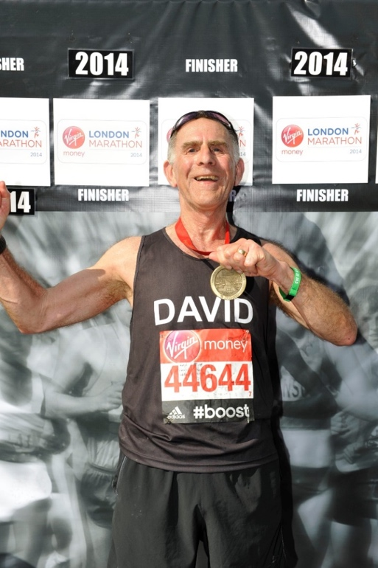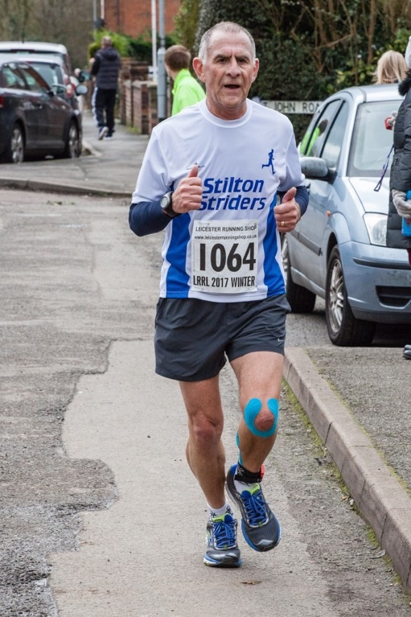

“Although I have tried to be physically active throughout my life – with limited success – I didn’t take up running until I was 57. I had started going to the local gym once a week, and then I began doing a 6-mile run each week on my own – Lag Lane mostly - just to maintain some level of fitness. Barbara, my wife, had joined in these activities, although we rarely ran together, and we still don’t!
“We decided to enter an event, such as a 10K, every 3 months just to give our ‘training’ some focus. Nowadays, instead of one event each 3 months, I often find myself doing 3 events each month!
“Barbara moved to another gym and a group of members were ‘persuaded’ by one of the instructors to form an informal running group. When I eventually moved to the gym, I also joined the running group, and from that group some long-lasting friendships have developed with a shared interest in eating and drinking, travel and drinking, and running and drinking. I run therefore I drink.
“My racing times slowly improved after my introduction to road running, but it was a slow process. It took me two years before I could achieve a sub 60-minute 10K, but my times gradually improved over the following years until I achieved my 10K PB and half-marathon PB in 2016.
“I was persuaded by my running friends to try a marathon. As this was likely to be my only marathon (it was!), we agreed to do the London Marathon in 2014, two months after my 65th birthday. I was feeling pretty confident as the training had gone well and the preparations went to plan. The first 15 miles were almost enjoyable: the sun was out, the crowds were out, my family and friends were there to support me and the pace was comfortable. But somewhere round Docklands I lost it and by the time I hit the 20-mile mark I was a broken man running in my own world of pain. I did finish in 4hr 45min, but I had been confident of getting close to 4:15, with a sneaky hope of closer to 4 hours. But I did it, I finished.

“My recovery wasn’t helped by a week’s walking holiday with my family and grandchildren beginning the day after the marathon, to belatedly celebrate my birthday (couldn’t break the training plan before the big day!). It took me a week to be able to walk properly and almost 3 months to be able to run at anything like my previous pace. But I did it and I won’t be doing it again!
“parkrun has also had a significant impact on my running. Not just the opportunity to blast out a 5K tempo run each Saturday – or a more leisurely run if I choose – but the number of runners that make this as much a social occasion as a sports event. I have met many runners on these Saturday mornings and the sense of community and friendship is almost tangible. The effects on these non-running elements of the parkrun have added a new aspect to my understanding of what it means to be ‘a runner’.
“I joined the Striders three years ago, in 2016, when the structured technical sessions were starting on a Thursday evening. I had found that, as the years advanced, recovery from injury was taking longer and longer. So, I argued to myself, why not join in with the experts to learn how to run properly and avoid, or at least reduce, injuries to my aging body. And this has been a success.
“That’s not to say that I don’t get injuries, but these are often the result of non-running incidents, like unloading the boot of a car! But, along with several other Striders, I discovered the effectiveness of Alistair Dickson at New Park Physiotherapy. While he doesn’t work miracles – yet! – he certainly points me in the right direction to rehabilitate any misbehaving elements of my running action.
“Joining the Striders has certainly added a new dimension to my running. I still run with my old friends and we still enter several road races together. But with the Striders I can enter other races and still find familiar friendly faces – the recently discovered social side of running has become increasingly important to me and I can be a bit more competitive!
“For me, being competitive is not about winning, or even beating someone, but it’s about measuring myself against me, what I’ve achieved before, what I consider myself capable of, what I want to achieve. Of course, being able to compare yourself to runners of a similar age is a useful measure as well, especially when you move up into a new age group, as I did this year!
“Running has been my exercise and therapy for several years. Long may it continue!”

