- Go to the England Athletics website
http://www.englandathletics.org/

- Select “Athletes” menu, then “Athlete Portal” 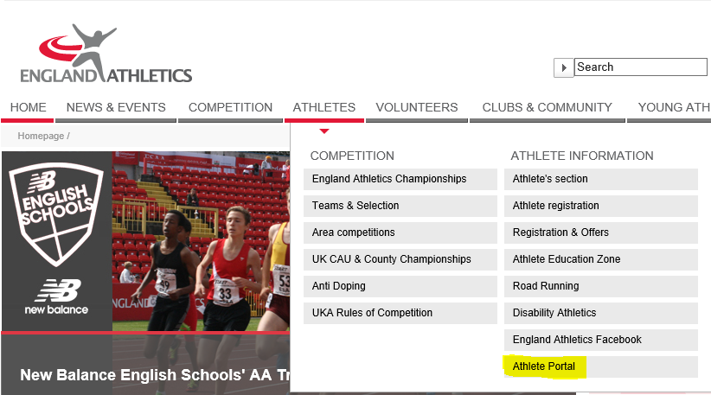

- Sign in, using your username (UK Athletics number) – shown on your membership card
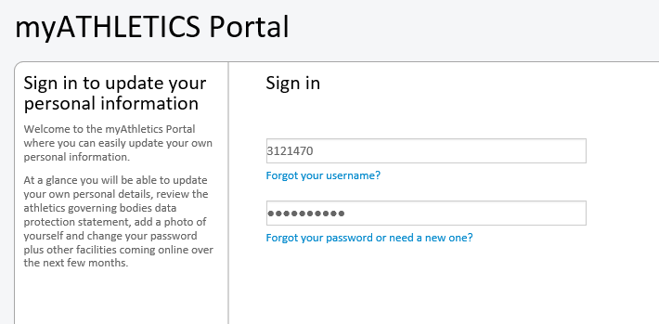

- Select “Personal Details”
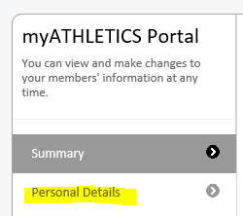

- Enter emergency contact number and name
